Bio – Sheryl Hardin
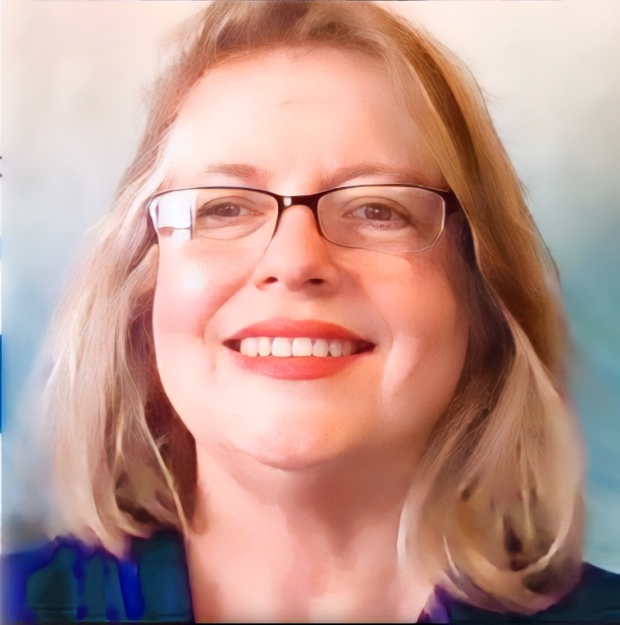
Credentials
Change Management
Speaking/Facilitation/Consulting
Clients
10,000 Small Businesses
(Babson College / Dallas College)
Brass Tacks Collective
Consumer and Market Insights
Dallas College (Richland)
Enactus UTD
Entrepreneur’s Connection
Emerging Leaders (SBA)
Ft. Worth & Tulsa PMIs
Hewlett Packard
Rexel USA
Rockwell Collins (now Alcatel)
MedOps
MetLife (DA&R & ASPE)
Local Profile (Collin County)
Securus Technologies
Six Flags Theme Parks
Smithsonian
Zurn Industries
Speaking Topics
Business Operations
Change Management
Process Improvement
Fractional Leadership
Business Management
Culture & Communications
Writer and Editor
Contact, Intercom, Hub Pages
Yahoo Voices, PMI Lessons Learned: Our Experiences from Managing IS Projects
Education
BS in Business:
University of Texas at Dallas
(Magna Cum Laude)
Sheryl Hardin is a Fractional COO, consultant, speaker and the author of Building Business Capacity. She has a passion for Organizational Change Management (OCM) and continuous process improvement. Sheryl is a successful entrepreneur and Founder of Business Solutions Consulting. She enjoys assisting companies as they create a business strategy, manage change, prepare for rapid growth, and improve processes. She can often be found speaking and consulting as a national speaker, seminar leader, adjunct faculty instructor, and business advisor. Sheryl supports programs like the Goldman Sachs grant funded initiative,10,000 Small Businesses (10ksb) designed by Babson College and the Institute for the Economic Empowerment of Women program Peace Through Business because they are creating positive change by supporting Small Business.
Sheryl uses carefully planned operational analysis and process improvement strategies that inspire operational best practices. Her speaking engagements are informed by real business experience. She strives to make sure that participants walk away with new skills and strategies they can begin using the same day. Her wor includes organization impacting activities like those listed below:
- Consulted with PnewSoft start up to become the premier fire inspection software in the nation
- Launched Dallas 10ksb alumni program while serving as Operations and Process adjunct faculty
- Served as a mentor for Peace through Business boot camps
- Developed Technical Writer coursework for Dallas College at Richland in order to train students to write procedures
- Worked with Hewlett Packard to integrate recently purchased small company while also reducing translation costs
- Consulted with several businesses as they grew through acquisition such as Genband, Securus Technologies, Six Flags Theme Parks, Zurn Industries, and Coty Inc.
- Received Francois Coty award 2017 (Global PMI Team)
As a consultant, Sheryl focuses on quelling the chaos that comes from infrastructures that are not properly sized to support an organization and operations that do not support best practices. Her special skill is finding the pieces of the puzzle that support rapid change. Sheryl consults with companies of all sizes who use change opportunities such as mergers, acquisitions, rapid growth, and strategic realignment to improve efficiency and effectiveness. Her experience spans a number of industries such as mortgage services, manufacturing, distribution, health care, military services, telecommunications, transportation, and software development.
Her goal as a speaker is to facilitate business education experiences that participants can use to take useful action immediately. She is available to consult with or serve on Advisory Boards for companies looking to scale.

